**methods of Graphical offline programming**

**1. The first part is installs offline programming software:**

（It is recommended to turn off the antivirus software of the computer during installation.）

1.1 Decompress the **Makecode V2.0 offline programming software.zip** provided by us to obtain the offline programming software of the folder Makecode V2.0, as shown in Figure 1.1 and Figure 1.2 below.

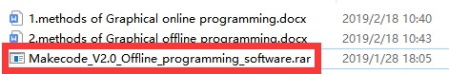

Figure 1.1

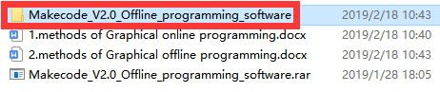

Figure 1.2

1.2 Enter the folder, you can see Makecode V2.0.exe, as shown in Figure 1.3 below, double-click the application to install.



Figure 1.3

1.3 You need to choose the option to create a shortcut on the desktop, as shown in Figure 1.4 below, so that after the installation is complete, a shortcut will be generated on the desktop.

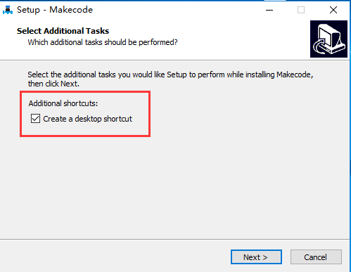

Figure 1.4

1.4 You need to wait for installation to complete. This icon appears on the desktop after the installation is complete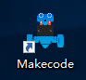。

**2. The second part is how to use offline programming software:**

2.1Open a shortcut on your desktop,  you can enter the offline programming interface, as shown in Figure 2.1.

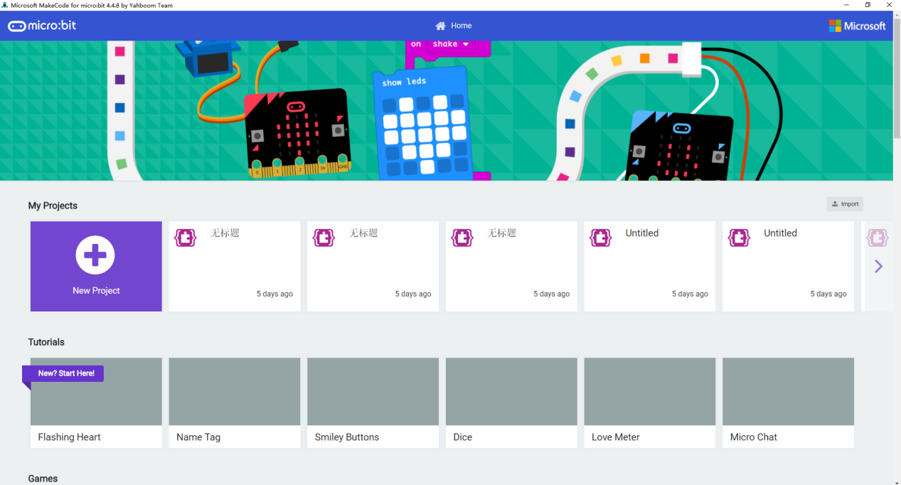

Figure 2.1

2.2 Click the [New Project] option in the interface to enter the programming page, as shown in Figure 2.2.

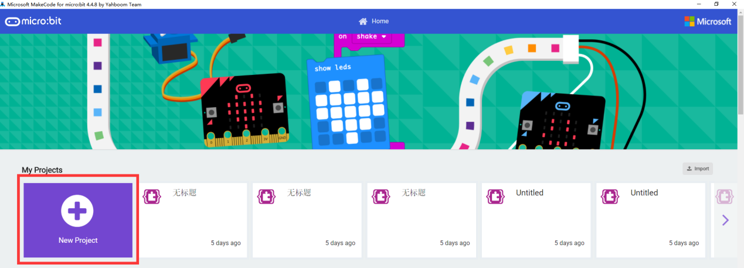

Figure 2.2

2.3 The interface shown in Figure 2.3 below is the micro:bit offline programming interface we need to use.

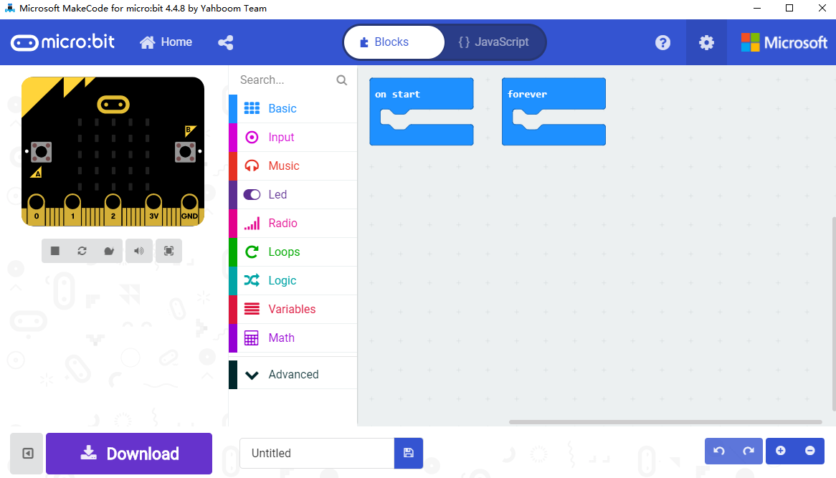

Figure 2.3

2.4 Click the icon in the upper right corner to switch languages, as shown in Figure 2.4.

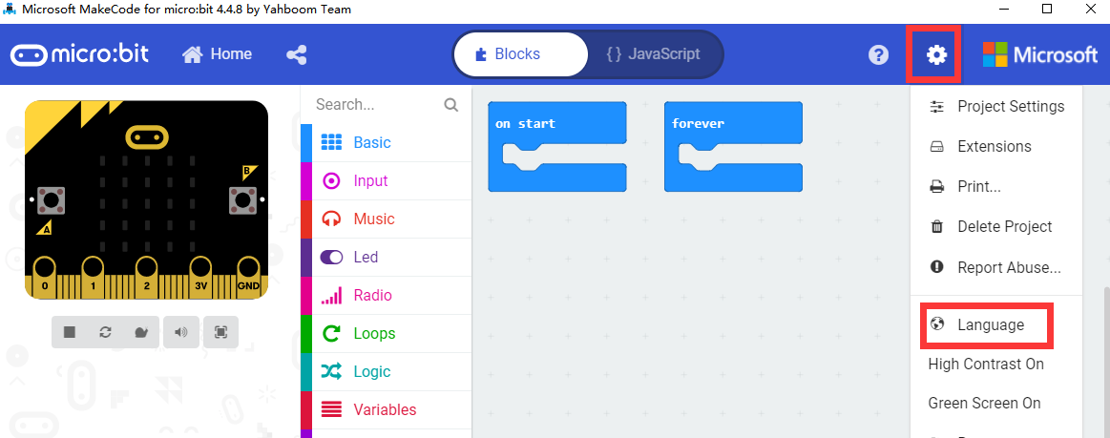

Figure 2.4

2.5 We first need to add the Yahboom package. In the interface shown in Figure 2.5 below, click 【Advanced】, then click 【Extensions】, an interface will pop up.

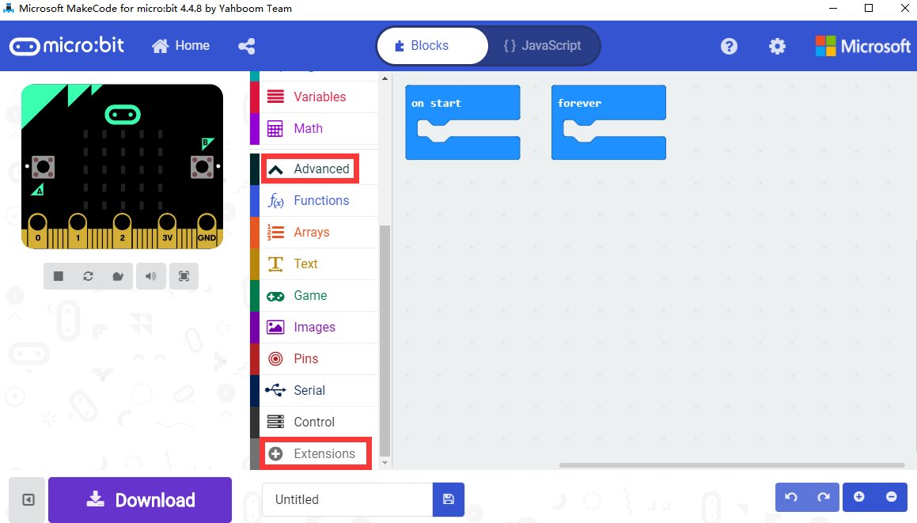

Figure 2.5

2.6 Enter the URL in the input field: **https://github.com/lzty634158/YB_Piano**. Then click "Search" or press the "Enter" key on the keyboard, as shown in Figure 2.6. You can search for the Yahboom software package, and then click piano, as shown in Figure 2.7, you can successfully add the software package.

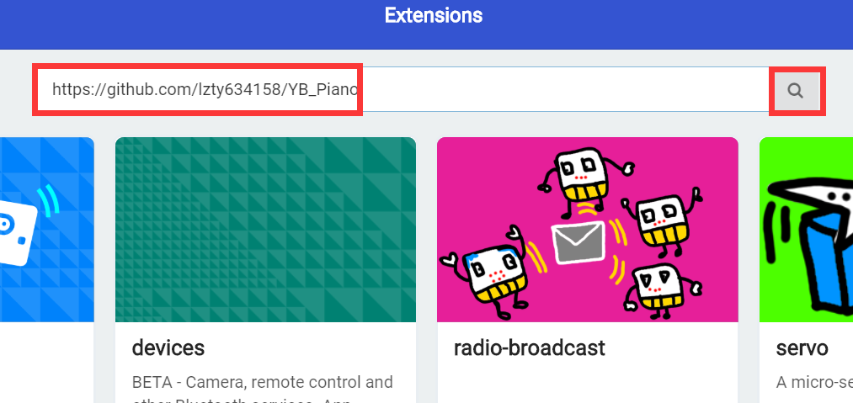

Figure  2.6

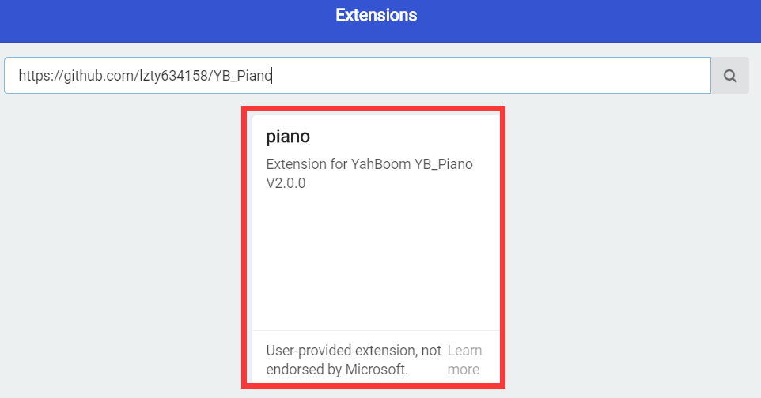

Figure 2.7

2.7 After loading the package, we can see that the program bar has loaded the building blocks made by Yahboom, as shown in Figure 2.8.

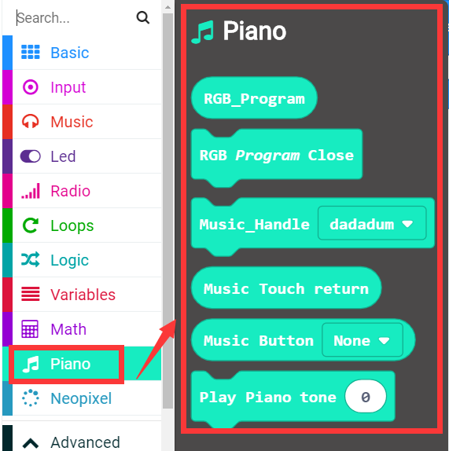

Figure 2.8

2.8 You can build your own building blocks for programming. After setting up the program blocks, we can name the program ourselves, and then click 【Download】 to download the program, as shown in Figure 2.9. We can set the download path to micro:bit U disk, or directly to the computer, and then copy it to the micro:bit U disk, as shown in Figure 2.10.

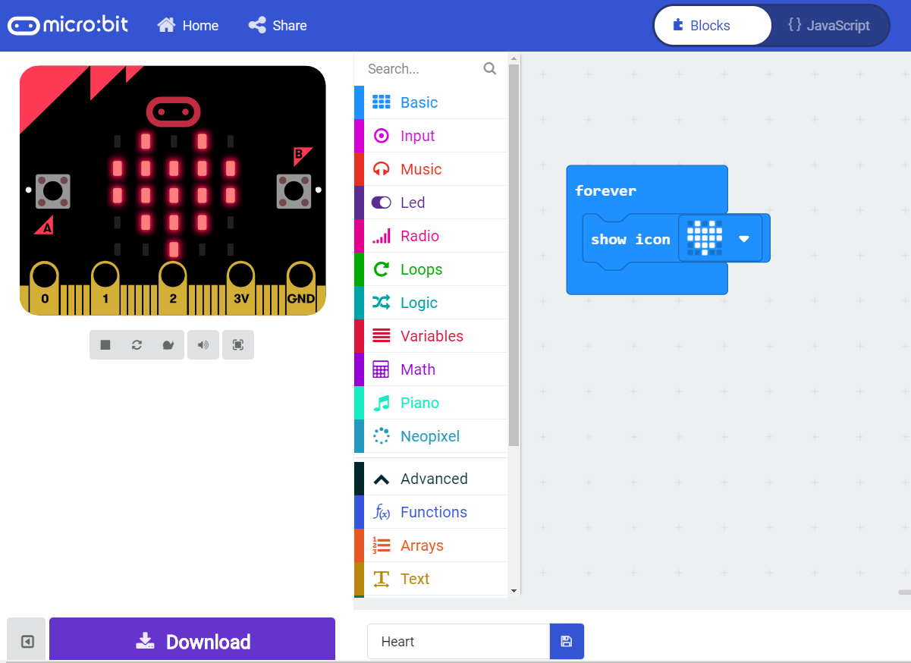

Figure 2.9

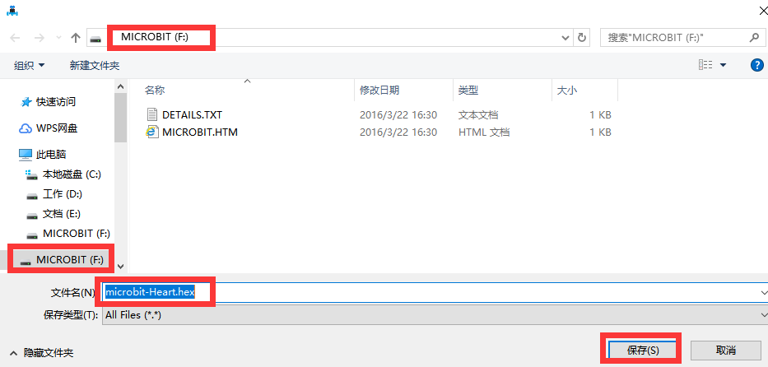

Figure 2.10

2.9 During the download, the indicator light on the back of the micro:bit motherboard will flash, as shown in Figure 2.11. After the download is complete, the indicator light stops flashing, and we can see the corresponding experimental phenomena and effects, as shown in Figure 2.11.

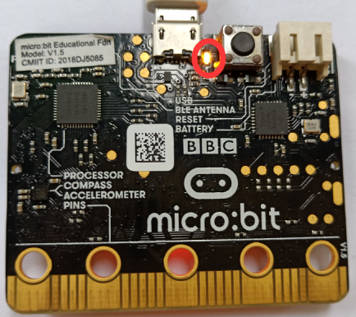 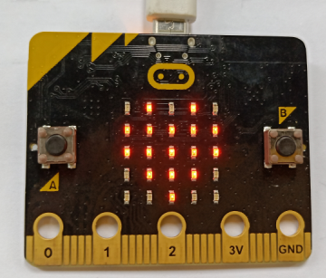

Figure 2.11 Figure 2.12